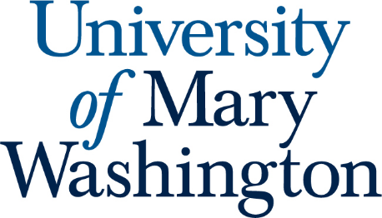

FSEM Committee
March 24th, 2025 Regular Meeting
Time and Location: 4-5pm, DuPont324

Meeting called to order: 4:04pm

In attendance:

2024-2025 FSEM Committee
- 2025 Bridgette Dennett, Chair (Assistant Professor, CAS)
- 2025 Marcus Leppanen, Secretary (Assistant Professor, CAS)
- 2025 Virginia Mackintosh (Associate Professor, CAS)
- 2026 Gary Richards (Professor, CAS)
- 2027 Ginny Morriss (Assistant Professor, CAS)

EX OFFICIO MEMBERS
- April Wynn, Director of the First-Year Experience

Guest Member (Non-voting role)
- October Edwards, Research and Instruction Librarian
- Old Business:
  - Spring Proposals
    - Still no proposals from any faculty
- New Business:
  - 2025 Call for Proposals
    - Need to update the call for proposals to align with SLOs for upcoming submissions
    - The committee discussed providing faculty with more flexibility in what fulfills the speaking SLO (e.g., greater emphasis on classroom discussion instead of presentations)
      - SLO cannot be updated quickly enough to reflect discussions but the committee has the final say in how it assesses future submissions with respect to SLO discussion
  - Committee spoke at length about broader issues related to the First Year Experience Advisory work
- Upcoming Meetings:
  - April 21st from 4-5 at Rey Azteca

Meeting adjourned: 4:59pm

