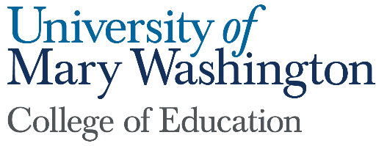

Dean’s Report
Submitted by: Pete Kelly
November 2022

- The College of Education, in collaboration with the Stafford County Public Schools, submitted a proposal for a Lab School planning grant in early October. We are told the review process will prioritize geographic distribution, and ours will be the only proposal in superintendent region three. The plan is to develop a STEM-focused high school in the south building on our Stafford campus to open in the fall of 2024. Teachers will utilize interdisciplinary teaching, hands-on problem-based learning and service learning approaches, incorporating a professional development school model (PDS). The PDS, similar to the teaching hospital, will create an environment for COE students to develop and learn innovative approaches to teaching.
- The College of Education, in collaboration with the Stafford and Spotsylvania County Public schools, and the Fredericksburg City Schools was awarded an Apprenticeship Planning Grant from the Virginia Department of Education. The federal government recognized teaching as an apprenticeable profession in 2021. Meetings with our K-12 colleagues are underway to identify and recruit teachers’ aides and long-term subs as apprentices, and develop professional development programs leading to teacher licensure. This is focused student recruitment, and also one more way the COE is working hand-in-hand with our K-12 partners to address the teacher shortage.
- The COE is leveraging faculty and staff expertise, and the new Makerspace in Seacobeck Hall to help increase capacity for STEM education together with our partner schools in a number of ways. We hosted a field trip for 150 elementary students from Spotsylvania schools, and facilitated learning experiences in chemistry, physics, biology, and the earth sciences, while engineers from Dahlgren provided a series of robotics demonstrations. We have three additional field trips scheduled this month. In addition, we provided professional development for all the Instructional Technology Resource Teachers from the Stafford County Public Schools.
- COE graduate students are preparing to start their spring semester long internship/student teaching. Many of them have applied to complete their internships as teachers of record in our partner schools. This is the third year for our residency-like program designed to help districts address the teacher shortage while also retaining Masters’ students in our graduate programs. For these residency positions, students are carefully vetted, interviewed, and provided with additional support given they will not teach alongside Mentor Teachers. Last year, about 20% of our interns also served as teachers of record through this approach.

