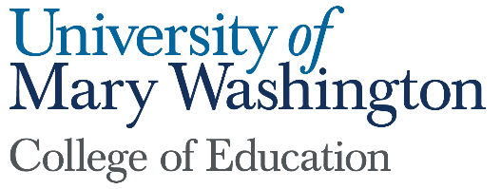

Dean’s Report
Submitted by: Pete Kelly
September 2022

As you well know, there is a serious teacher shortage in Virginia. It is important you know we are working in partnership with school divisions in the region to help address this shortage in a number of ways. Our efforts on that front are outlined below.
- Recruitment:
  - We are continuing our Teachers For Tomorrow (TFT) collaborations with three school divisions. TFT is a VDOE curriculum for high school students interested in being teachers, and is seen as a “grow your own” teacher program. We visit their classes, offer scholarships, and we host a TFT Summer Institute on campus (as a part of the Summer Enrichment Program) to nurture and encourage HS students to be teachers. During the summer of 2022, we had 20 students from 11 school divisions and 15 different VA high schools. We expect to extend these collaborations to other school divisions.
  - We are in year three of rolling out our undergraduate programs in education while also teaching out our five-year programs.
  - In response to the increasing number of provisionally licensed teachers in Virginia, last year we streamlined our Post bac programs (for re-career students) and will offer them in eight-week sessions customized to meet needs of cohorts from partner school divisions. We had multiple meetings over summer 2022 focused on meeting the needs of provisionally licensed teachers in the area.
  - A group of faculty from across campus drafted a Noyce/NSF grant to support the recruitment and preparation of STEM teachers with a particular focus on teachers of color. This is a significant grant that would provide important resources to help address a serious shortage issue in the state.
- Preparation: We are developing professional development school (PDS) partnerships in five area elementary schools. PDS partnerships are collaboratively developed and mutually beneficial. We will place practicum and intern students to facilitate their development as teachers, while also helping to improve teaching and learning in partner schools. These partnerships will be collaboratively developed focused on mutually beneficial clinical experience, professional development, and contextualized inquiry.
- Retention: We are in year seven of our Pathways to Excellence program focused on building capacity for mentorship in school divisions in the region. Evidence suggests that teachers in their first three years of teaching provided with effective mentorship support are more likely to stay in the profession. We have trained over 300 mentor teachers to provide induction support for new teachers, and for COE interns. Trained mentors serve as “Clinical Faculty” for COE students completing internships while also providing induction support for new teachers. This mutually beneficial collaboration is expanding its reach in collaboration with the state-wide MentorVA initiative, and should improve teacher retention in the area.

