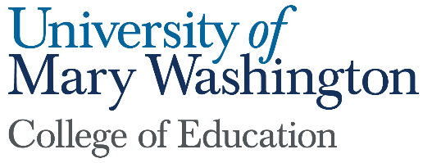

Dean’s Report
Submitted by: Pete Kelly
February 1, 2022

- Seacobeck Hall: The COE moved into our new building during winter break and we are offering courses this semester. The state-of-the-art classrooms, makerspace, curriculum lab and extensive collaboration spaces will help us recruit and prepare people into the profession, and we need them now more than ever. The state’s chronic, long-term teacher shortage continues to be exacerbated by the pandemic and the politicization of the teaching profession. The completion of Seacobeck could not have come at a better time.

- Recruitment: Teachers for Tomorrow (TFT) is a curriculum for high school students interested in becoming teachers. TFT programs are seen as effective “grow your own” teacher programs, and important recruiting opportunities for Mary Washington’s Colleges of Education. The COE is continuing its TFT collaborations with area school divisions including Stafford, and Spotsylvania County Public Schools, and Fredericksburg City Schools, focused on the following initiatives:
  - Campus visits for Teachers for Tomorrow students and teachers: Three TFT Programs from three different high schools were hosted during fall 2021. Additional visits are scheduled for spring 2022.
  - Teachers for Tomorrow Summer Institute Summer 2022: Weeklong residential enrichment program to nurture and develop high school students’ knowledge and skills relevant to the teaching profession

- Preparation: The development of co-constructed, mutually beneficial partnerships is integral to effective teacher preparation. These collaborative and mutually beneficial initiatives aim to enhance our teacher preparation while simultaneously helping improve teaching and learning in our partner schools:
  - After school tutoring programs at Drew Middle School and Hazel Hill
  - Clinical partnership development with school-based K-12 colleagues
  - College of Education Testing Center to provide tutoring & support for required licensure exams; program administration provided by the Director of Advising
  - Teacher residency arrangement with Fredericksburg, Spotsylvania, and Stafford Schools where COE graduate student’s complete internship requirements while also serving as Teachers of Record. We currently have 19 carefully vetted and supported students completing these residency-like arrangements.

- Retention: High teacher turnover has significant negative impacts on student achievement, teacher morale, and increased recruitment and training costs. The provision of high-quality mentorship and induction support helps to alleviate problems associated with high teacher attrition. COE faculty and staff are working to increase capacity for mentorship for preservice teachers, and for induction support for early career teachers.
  - Pathways to Success Program is a year-long Mentor training program that is currently supporting 23 clinical faculty across three partner school divisions
  - The Pathways program develops mentorship skills of Clinical Faculty who serve as Mentor Teachers for teacher candidates and teachers in their first three years of practice

