The Issue
The General Education requirements in effect starting in Fall 2020 stipulate that students need three writing intensive (WI) courses and one speaking intensive (SI) course under the Foundations category.
Major requirements starting in Fall 2020 stipulate that students need one WI and one SI in each major.
For students with one major, this results in a total of 4 WI classes and 2 SI classes. However, in the current implementation, double majors are being required to take 5 WI (3 for their general education requirements and one in each major) and 3 SI classes (1 for their general education requirements and one in each major)

Motion:
The UFC resolves, therefore, that WI and SI courses taken for a second major be allowed to fulfill the general education requirements, such that no student (who is a single or double major) is required to take more than 4 WI courses and 2 SI courses.

Justification:
According to the online version of the Academic Catalog, which is the definitive form of the catalog, the general education requirements include (but are not limited to):
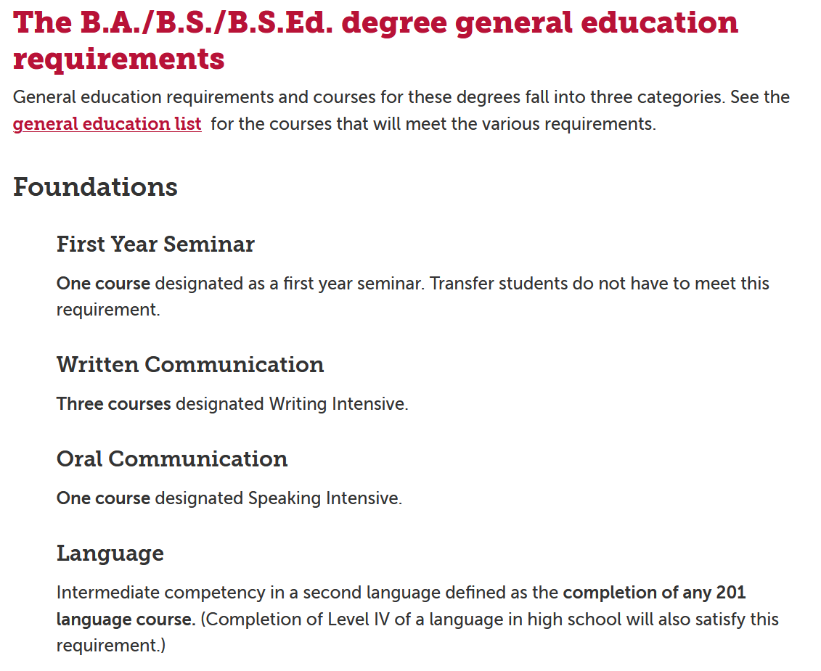
There is no requirement for a certain number of WI or SI courses to be taken outside of the major, so allowing a WI or SI course in a second major to count for the general education requirements is consistent with current policy. The current interpretation of policy puts an undue burden on students who wish to double major, thereby potentially decreasing the number students declaring and graduating with two majors. From an institutional perspective, this also presents a problem for major programs that are often selected as a second major for our most aspiring students. We do note that in the exceptionally rare case of a triple major, students would be required to take 3 SI classes (one in each major).

