PROPOSAL to the UAAC to change the minimum GPA
of UMW’s Guaranteed Admissions Agreement (GAA) with the
Virginia Community College System (VCCS) to a 3.0

January 2020

Rationale/Background
The current GAA sets a minimum 3.25 GPA that is higher than several competitors in the Commonwealth [e.g. James Madison (3.0), George Mason (2.85), Radford (2.8), Old Dominion (2.5), VCU (2.5), Longwood (2.5)]. This puts UMW at a significant competitive disadvantage when recruiting transfer students (who are and will continue to be a critical piece of our enrollment strategy).

Admissions counselors from both UMW and 2-year transfer partners often comment that the GAA GPA is viewed by students as a minimum necessary for enrollment (not understanding that this is just the minimum necessary to exercise the privileges of the GAA). Such confusion is often compounded by the communications students receive at the 2-year institution. For example, the following is a picture taken of posters created by and hung on billboards by of one of our community college partners.

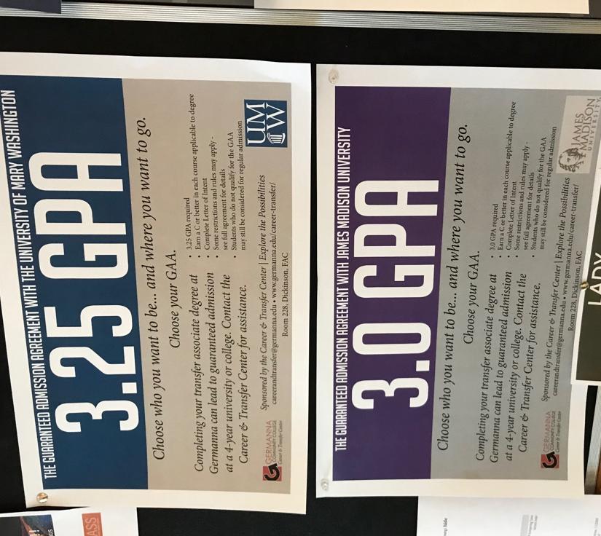

How many students come in through the GAA?
UMW has not coded these for the past few years (although the Office of Admissions is beginning to do this once again with the current cycle). Prior to this lapse, UMW averaged approximately 50 students per year from 2008 through 2015.

What would changing the agreement involve?
Originally signed in 2012 it would involve the following two changes to UMW’s Guaranteed Admissions Agreement with the VCCS:

“GAA student” refers to a student who graduates from a transfer degree program at a Virginia community college with a cumulative VCCS grade point average (GPA) of 3.25 3.0 or higher on a four-point scale and who intends to transfer to UMW.

To be guaranteed admission to UMW, students must complete the requirements to become GAA students (graduation from a transfer degree program at a Virginia community college with a cumulative grade point average (GPA) of 3.25 3.0 or higher on a four-point scale with intent to transfer to UMW) and submit an official transcript showing completion of the associate degree to the UMW Admissions Office.

Language in the Academic Catalog would need to be similarly revised (i.e. p.19 of the 2019-2020 catalog).

To be guaranteed admission to UMW, students must complete the requirements to become GAA students (graduation from a transfer-oriented degree program at a Virginia community college with a cumulative grade-point average (GPA) of 3.25 3.0 or higher on a four-point scale with intent to transfer to the University of Mary Washington) and submit an official transcript showing completion of the associate degree to the UMW Admissions Office.

