M E M O R A N D U M
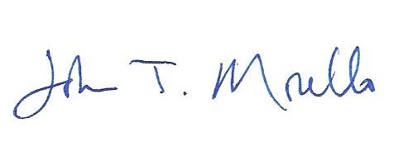

TO: University Academic Affairs Committee (UFAC)

FROM: John T. Morello, Associate Provost

DATE: December 13, 2019

SUBJECT: Changes needed to the Undergraduate Catalog – to enable PHYD 130 to be offered on a graded basis (not SA/UN) so that it may count in the Sports Management Minor

The Issue. The Catalog statement of parameters governing PHYD courses is in conflict with a course numbering change for the Sports Management minor submitted in December 2019. The proposal was that IDIS 130 (Introduction to Sports Management) be changed to PHYD 130. This was an expedited course action that was approved by the CAS Curriculum Committee, posted for the requisite number of days, and received no objections. Two sections of the Undergraduate Catalog need to be changed.

Catalog sections on Satisfactory/Unsatisfactory grades and the description of the program in the Physical Education section of the Catalog need to be revised. The University Academic Affairs Committee approved changes to these same two sections in February 2018 to accommodate PHYD 330 and 499.

The Remedy. Language in the Undergraduate Catalog should be amended as follows (changes in red):

SATISFACTORY/UNSATISFACTORY GRADE
With the exception of PHYD 130, PHYD 330, and PHYD 499, all other physical Education courses and 100-level (DANC) courses are graded as either satisfactory (SA) or unsatisfactory (UN). With the exception of PHYD 330 and 499, no more than two credits of physical education (PHYD) courses may be taken in a single semester (or complete summer session). Excluding PHYD 130, PHYD 330, and PHYD 499, a maximum of 8 credits in other physical education (PHYD) courses may be included in the credits required for graduation. With the exception of PHYD 130, PHYD 330, and PHYD 499, a BLS student may take a maximum of 6 other PHYD credits toward the degree. With the exception of PHYD 130, PHYD 330, and PHYD 499, a student may not take two sections of the same PHYD or DANC course in a semester, regardless of level. A student may take up to one pass/fail and two satisfactory/unsatisfactory courses in the same semester.

The statement currently on page 194 (printed Catalog)
Most physical education courses focus on history, rules, and basic techniques in individual and team sports. Riding courses are available for credit but require a special fee. All Physical Education individual and team sports courses (except PHYD 314) may be repeated for additional credit, but no more than eight credits earned in individual and team sports courses may be counted toward the 120 credits required for graduation. If two sections of the same individual and team sports course are taken in one semester, only one will count toward degree requirements. With the exception of PHYD 130, PHYD 330 and PHYD 499, all other Physical Education (PHYD) courses are graded satisfactory/unsatisfactory (SA or UN grades) and may not be taken for a letter (A-F) grade. PHYD courses taken as SA/UN do not ever count toward a student’s grade point average. PHYD 130, PHYD 330 and PHYD 499 letter (A-F) grades do count toward a student’s grade point average.

