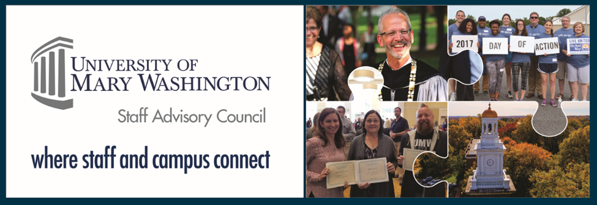

Staff Advisory Council Update for UFC
January 29, 2020

- The February SAC meeting on Thursday, February 20th 1-3pm will be screening the James Farmer documentary, The Good Fight, James Farmer Remembers the Civil Rights Movement. This meeting will also have a brief discussion regarding student employment by committee members Beth Williams and Julie Smith. The monthly meeting will be held in Lee Hall, Room 412.
- SAC is supporting a school supply drive through the end of February to benefit Hugh Mercer Elementary. There is a drop-off location in Lee Hall.
- The sixth annual Chili-Cook-off is scheduled for March 4th in Chandler Ballroom.

